**Risk Assessment Template**

You may need to carry out different risk assessments for:

* Community building premises
* Activities that take place onsite (including a risk assessment for room hire)
* Activities that take place offsite

# **How to complete a Risk Assessment:**

When conducting a risk assessment, [HSE sets out what steps to take to manage risk at work](https://www.hse.gov.uk/simple-health-safety/risk/index.htm), including:

**1. HAZARD -** What is the hazard you have identified? What could happen if left unaddressed?

**2. WHO -** Who is at risk from this hazard?

**3. EVALUATE -** Score the risk of harm (Keep the metric as simple and clear as possible so you can compare over time following actions to reduce risk).

You will need to consider

* What is the likelihood or probability of this hazard?
* What would be the impact of this hazard, if it occurred?

You may find it helpful to use a matrix to assess the overall level of risk posed by this hazard:

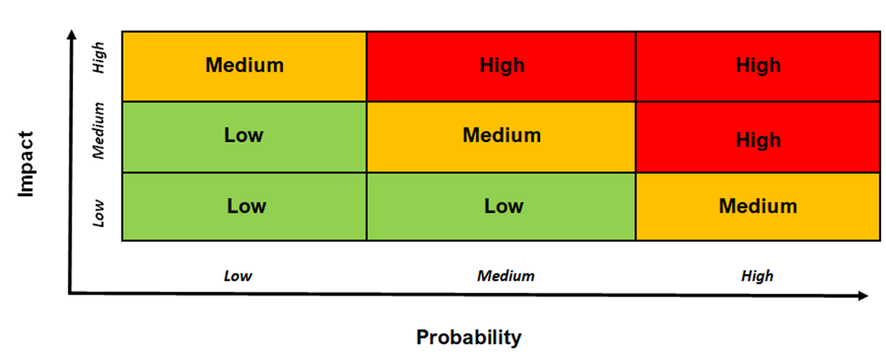

**4. ACTION -** What steps are you taking to reduce or remove the hazard? It is essential that all actions are communicated to staff involved in delivery of an activity.

**5**. **REVIEW** regularly. It is best practice to have a risk assessment reviewed and signed off by a designated lead or health and safety officer.

[See the Health and Safety Executive’s guidance on managing risk in the workplace](https://www.hse.gov.uk/simple-health-safety/risk/steps-needed-to-manage-risk.htm#article)

|  |  |  |  |  |  |  |  |  |
| --- | --- | --- | --- | --- | --- | --- | --- | --- |
| **Event/Activity (What and Where?)** | **Identified Hazard** | **Who is at risk?** | **Likelihood**  **(Low, Med, High)** | **Impact**  **(Low, Med, High)** | **Action (s) to reduce risk** | **Impact after action taken**  **(Low, Med, High)** | **Review date and location** | **Name of assessor** |
|  |  |  |  |  |  |  |  |  |
|  |  |  |  |  |  |  |  |  |
|  |  |  |  |  |  |  |  |  |
|  |  |  |  |  |  |  |  |  |

**Examples of completed risk assessments are available at:**

* <https://www.hse.gov.uk/simple-health-safety/risk/risk-assessment-template-and-examples.htm>
  + [Office-based business](https://www.hse.gov.uk/simple-health-safety/assets/docs/office.pdf)
  + [Local shop/newsagent](https://www.hse.gov.uk/simple-health-safety/assets/docs/newsagent.pdf)
  + [Food preparation and service](https://www.hse.gov.uk/simple-health-safety/assets/docs/foodprep.pdf)
  + [Warehouse](https://www.hse.gov.uk/simple-health-safety/assets/docs/warehouse.pdf)
* [Haringey Council Risk Assessment Template for a community event](https://www.haringey.gov.uk/sites/haringeygovuk/files/event_risk_assessment_template.doc)
* [Frome Town Council – Example Risk Assessment for a community event](https://www.frometowncouncil.gov.uk/wp-content/uploads/2016/02/Example-Risk-Assessment-for-a-Community-Event.pdf)