**Risk Assessment Template**

You may need to carry out different risk assessments for:

* Community building premises
* Activities that take place onsite (including a risk assessment for room hire)
* Activities that take place offsite

# **How to complete a Risk Assessment:**

When conducting a risk assessment, [HSE Risk Assessments guidance](https://www.hse.gov.uk/violence/toolkit/riskdetail4.htm) lists 5 key things to include:

**1. HAZARD -** What is the hazard you have identified? What could happen if left unaddressed?

**2. WHO -** Who is at risk from this hazard?

**3. EVALUATE -** Score the risk of harm (Keep the metric as simple and clear as possible so you can compare over time following actions to reduce risk).

You will need to consider

* What is the likelihood or probability of this hazard?
* What would be the impact of this hazard, if it occurred?

You may find it helpful to use a matrix to assess the overall level of risk posed by this hazard:

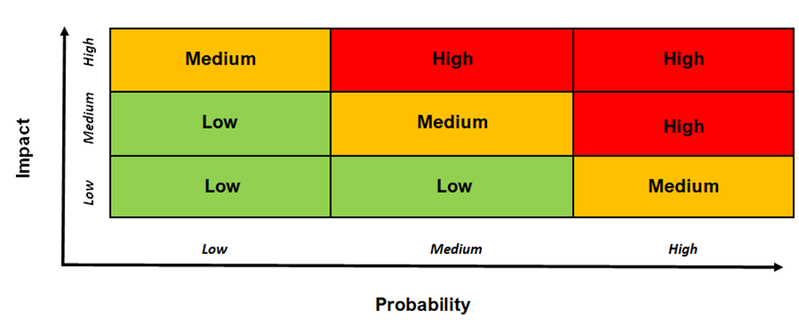

**4. ACTION -** What steps are you taking to reduce or remove the hazard? It is essential that all actions are communicated to staff involved in delivery of an activity.

**5**. **REVIEW** regularly. It is best practice to have a risk assessment reviewed and signed off by a designated lead or health and safety officer.

[**See the Health and Safety Executive’s guidance on managing risk in the workplace**](https://www.hse.gov.uk/simple-health-safety/risk/steps-needed-to-manage-risk.htm#article)

|  |  |  |  |  |  |  |  |  |
| --- | --- | --- | --- | --- | --- | --- | --- | --- |
| **Event/Activity (What and Where?)** | **Identified Hazard** | **Who is at risk?** | **Likelihood**  **(Low, Med, High)** | **Impact**  **(Low, Med, High)** | **Action (s) to reduce risk** | **Impact after action taken**  **(Low, Med, High)** | **Review date and location** | **Name of assessor** |
|  |  |  |  |  |  |  |  |  |
|  |  |  |  |  |  |  |  |  |
|  |  |  |  |  |  |  |  |  |

**Examples of completed risk assessments are available at:**

* <https://www.hse.gov.uk/simple-health-safety/risk/risk-assessment-template-and-examples.htm>
* <https://www.ardsandnorthdown.gov.uk/images/assets/Risk_Assessment_for_small_and_community_events.pdf>
* https://www.hse.gov.uk/violence/toolkit/riskdetail4.htm